
Safeguarding Bulletin – May 2023

Welcome to the Safeguarding Update for May. There are a number of events taking place during May, the most notable being the celebration of the King’s Coronation. In Liverpool, we also have the Eurovision Song Contest, being held in place of Ukraine. This will be the 9th time Eurovision has been held in the UK. Naturally both events are going to bring lots of tourists to the areas and with this in mind, the national security alert has been increased to SUBSTANTIAL which means an attack is likely. Please make sure that you make your learners aware of this to keep themselves safe.

May Day - 1st May 2023 – Bank Holiday in the UK and Ireland
May Day is an ancient pagan spring festival, traditionally celebrated across Europe with maypole dancing and the crowning with a floral crown of a May Queen.

Screen-Free Week - 1st May to 7th May 2023 - https://www.screenfree.org/resources-for-families-individuals/
Screen-Free Week is an annual invitation to play, explore, and rediscover the joys of life beyond ad-supported screens. During the first week of May, thousands of families, schools, and communities around the world will put down their entertainment screens for seven days of fun, connection, and discovery.
Even though it’s about turning off screens, Screen-Free Week isn’t about going without – it’s about what you can get! An hour once dedicated to YouTube becomes an hour spent outside; ten minutes whiled away on social media turn into ten minutes spent doodling.
You can celebrate Screen-Free Week at home, in your school, in your community, or anywhere – just put down those entertainment screens and do literally anything else! You might be surprised at what you find. Plan a day, a few hours, or the whole week; however you participate is great!

(“Entertainment screens” means that you can’t use Screen-Free Week as an excuse not to do your homework or your job. But if you’re a teacher or boss, you can help everyone celebrate by reducing the amount of screen-based work you assign!)

World Asthma Day - 2nd May 2023 – www.ginasthma.org
An annual event organized by the Global Initiative for Asthma with a goal to improve asthma awareness and care around the world. World Asthma Day (WAD) (May 2, 2023) is organized by the Global Initiative for Asthma, (GINA), a World Health Organization collaborative organization founded in 1993. WAD is held each May to raise awareness of Asthma worldwide.
GINA has chosen “Asthma care for All” as the theme for the 2023 World Asthma Day. GINA aims to increase and strengthen the link with local and national guideline makers. GINA also commits to ensure specific recommendations for environmental sustainability by sharing concerns about planetary health with a high priority on patient safety. GINA is working to improve the lives of people with asthma globally, and multi-faceted collaboration for improvement in all aspects of asthma care, for patients and for the environment is vital.

National Sun Awareness Week - 1st – 7th May https://www.bad.org.uk/sun-awareness-week-2023/
National Sun Awareness Week informs of the dangers of excessive sun exposure and how to avoid sunburn and skin cancers. Members of the public to get involved in any way that they can – the key is raising awareness around sun protection and skin cancer – the most common cancer in the UK to date.
Sun Awareness Week marks the start of a summer long campaign to provide people with information so they can practice sun safety.
This year’s campaign focus will be on the need for sun protection in the UK climate, aiming to tackle misconceptions that sun protection is rarely needed in the UK.

Coronation of King Charles III - 6th May 2023 – https://thebighelpout.org.uk


The coronation of King Charles III and Queen Camilla will take place at Westminster Abbey London, as part of international celebrations across the Commonwealth for the new king.

What is the Coronation?

The Coronation is centred around a solemn religious ceremony that has remained largely unchanged for over 1,000 years and takes place at Westminster Abbey.

The Big Help Out
From Coronation Big Lunches to street parties, from rolling up your sleeves to help a local group, to supporting some of the UK’s best-known national charities, the Big Help Out on Monday 8 May will give everyone an opportunity to join in. Hundreds of activities are planned for the day by local community groups, organisations and charities including The Scouts, Royal Voluntary Service, National Trust and RNLI.

Coronation Bank Holiday
8th May 2023
This is an extra Bank Holiday in the UK to celebrate the Coronation of King Charles III.

Europe Day – 9th May 2023 - https://www.celebrateeuropeday.net
A day celebrating peace and unity in Europe. It is celebrated by displaying the Flag of Europe and commemorates the founding of the Council of Europe.
Europe Day celebrates Europe's achievements and unity and commemorates the signing of the Schuman Declaration on 9 May 1950. This ambitious plan to secure long-term peace in post-war Europe laid the early foundations for what is now the European Union.

World Fair Trade Day – 13th May 2023 - https://globaldimension.org.uk/calendar/world-fair-trade-day

A worldwide festival of events celebrating Fair Trade's contribution to sustainable development, and the economic empowerment of small producers, gender equality and responsible production. World Fair Trade Day is celebrated on the second Saturday of May and is endorsed by the World Fair Trade Association (WFTA), the global authority on fair trade. It's a day to raise awareness about Fair Trade projects and the need for a fairer global economy.

Eurovision Song Contest – 1st – 14th May - https://eurovisionworld.com/eurovision/2023/event

The 67th Eurovision Song Contest will be held in Liverpool at the Liverpool Arena. This year's event will celebrate last year's winners Ukraine, as well as Liverpool's enormous musical heritage. It will be the ninth time that the United Kingdom hosts the contest.
In addition to the main venue, the host city will also organise side events in tandem with the contest. The Eurovision Village is the official Eurovision Song Contest fan and sponsors area during the event weeks. At the Village, it will be possible to watch performances by contest participants and local artists, as well as the three live shows broadcast from the main venue. It is set to be located at the Pier Head, open from 5 to 13 May 2023. Entry to the Village is free of charge except during the final, when—for the first time—there is an entry fee.[A two-week cultural festival called EuroFest, will take place across Liverpool from 1 to 14 May 2023, and will feature collaborations between British and Ukrainian artists.

National Children's Day UK – 14th May 2023 - https://www.nationalchildrensdayuk.com/
National Children's Day UK is all about the importance of a healthy childhood and protecting the rights and freedoms of children so that they can grow into happy, healthy adults.

Mental Health Awareness Week – 15th – 21st May - https://www.mentalhealth.org.uk/our-work/public-engagement/mental-health-awareness-week
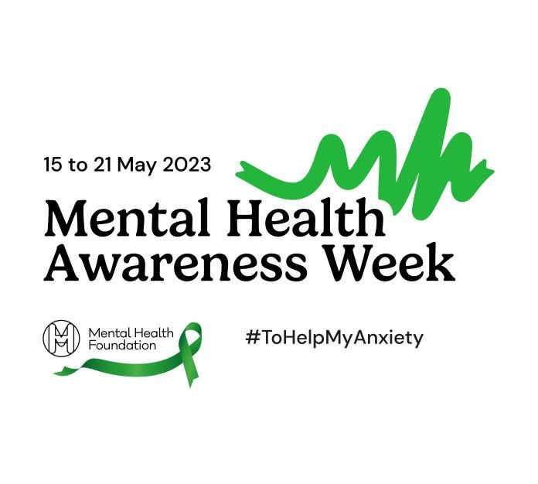
Anxiety is a normal emotion in us all, but sometimes it can get out of control and become a mental health problem.
Lots of things can lead to feelings of anxiety, including exam pressures, relationships, starting a new job (or losing one) or other big life events. We can also get anxious when it comes to things to do with money and not being able to meet our basic needs, like heating our home or buying food.
Anxiety is one of the most common mental health problems we can face. A recent survey showed that anxiety stopped people from doing the things they want to do some or all of the time. Six in ten adults feel this way, at least some of the time. On a positive note, anxiety can be made easier to manage. Focusing on anxiety for this year's Mental Health Awareness Week will increase people's awareness and understanding of anxiety by providing information on the things that can help prevent it from becoming a problem. At the same time, we will keep up the pressure to demand change - making sure that improving mental health is a key priority for the government and society as a whole.

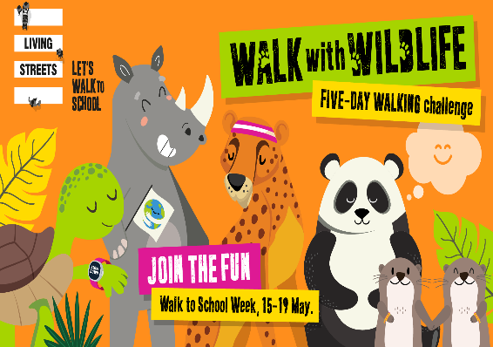
Walk To School Week – 15th – 19th May - https://www.livingstreets.org.uk/products-and-services/projects/walk-to-school-week

Annual event to encourage children and their parents to walk to school, organised by Living Streets. Many schools take part in the event, giving out badges to those who walk, cycle or roll to school. This year's challenge encourages children to travel actively to school every day of the week. Meeting various animals along the way, they'll learn about the important reasons to walk and the difference it can make for individuals, communities and the planet!

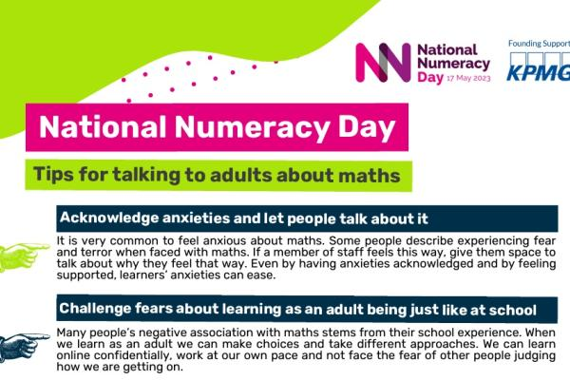
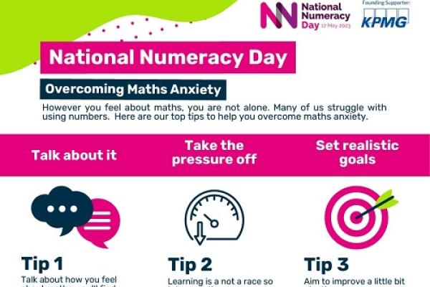
National Numeracy Day – 17th May 2023 - https://www.nationalnumeracy.org.uk/numeracyday
An annual celebration of the importance of numbers in everyday life and will bring together individuals, employers, educators and influencers to improve numeracy.

Africa Day - 25th May 2023 - https://nationaltoday.com/global-africa-day/
Africa Day (formerly African Freedom Day and African Liberation Day) I the annual commemoration of the foundation of the Organisation of African Unity on 25 May 1963. The day is marked with both speeches by political and social leaders, and concerts featuring cultural entertainment, poetry and speakers. It is celebrated in various countries on the African continent as well as around the world. The organisation was transformed into the African Union on 9 July 2002 in Durban, South Africa, but the holiday continues to be celebrated on 25 May.

National Biscuit Day - 29th May 2023 – https://nationalbiscuitday.co.uk

The 29th May each year is National Biscuit Day, so if you’re nuts about Ginger Nuts or more of a Custard Cream kind of a person ’m pretty sure we can all agree that May 29th is up there with one of the best awareness days. So however you plan to pay homage to this frankly awesome awareness day, I guess all that’s left to say is Happy Dunking!

Late Spring Bank Holiday
29th May 2023
The late spring Bank Holiday, held on the last Monday in May, was originally know as Whit Monday. The Whitsun weekend was traditionally a time for fairs, morris dancing and parades with brass bands.

SSS Module for May – Health and Safety
For all things safeguarding please do not hesitate to contact myself or Emma at.
caroline@jmet.org.uk
emma@jmet.org.uk
Referrals to. SafeguardingandPrevent@jmet.org.uk

